Given the sample space S = {1, 2, 3, 4, 5, 6, 7, 8, 9} with event A = {2, 4, 6, 8} and event B = {1, 2, 3, 4, 5}.
1. Draw a Venn diagram.
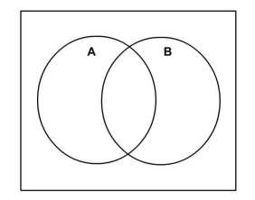

2. List all the outcomes for $A ∪ B$.

3. List all the outcomes for $A ∩ B$.

4. List all the outcomes for B^{c}.

The sample space S = {Blue, Yellow, Red, Purple, Green, Orange, Black, White} with event P={Red, Yellow, Blue} and event M = { Purple, Green, Orange, Black, Red}.

5. Draw a Venn diagram .

6. List all the outcomes for $P ∪ M$.

7. List all the outcomes for $P ∩ M$.

8. List all the outcomes for M^{c}.

9. What is $M ∩ M^{c}$?

10. What is ~P?

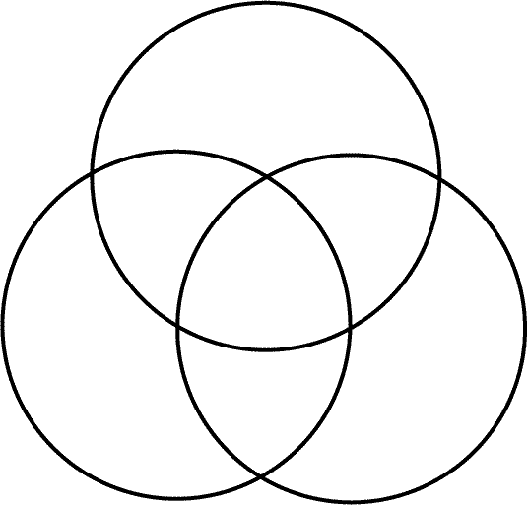
Let A, B and C be three sets such that: Set A = {2, 4, 6, 8, 10, 12}, set B = {3, 6, 9, 12, 15} and set C = {1, 4, 7, 10, 13, 16}.

11. What is A ∪ B
12. What is A ∩ B
13. What is B ∩ A
14. What is B ∪ A
15. What is B ∪ C?
16. Is A ∪ B = B ∪ A?
17. Is B ∩ C = B ∪ C

18. Shade the area on the Venn Diagram that represents the given event.
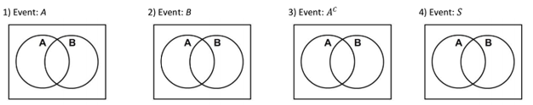
You have an equally likely chance of choosing an integer from 1 to 50. Find the probability of each of the following events.
19. An even number 20. A perfect square 21. A two digit is chosen

22. A multiple of 4 is chosen 23. A number less than 35 is chosen

You randomly chose two marbles, replacing the first marble before drawing again, from a bag containing 10 black, 8 red, 4 white, and 6 blue marbles. Find the probability of each of the following events.
24. A white marble, then a red marble is selected. 26. A red marble is not selected, then a blue marble is selected.

25. A green marble, then a green marble is selected. 27. A blue or black marble is selected, then a white marble is selected.

Drawing a card from the cards on the left, determine the probability of each of the following.
28. P(Even $∪$ shaded)
29. P(White $∪$ odd)
30. P(Less than four $∪$ shaded)
31. P(Greater than five $∪$ shaded)
32. P(Factor of ten $∪$ white)
Using the Venn diagram, answer the following questions.

33. P(girls)
34. P(~sports)
35. P(girls $∩$ sports)
36. P(sports $∪$ girls)
37. P(sports)

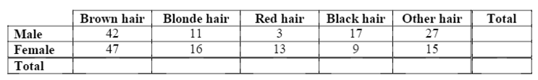
Find the marginal total. Then use the table to find the probabilities below.

20. $P\left(male\right)$ 21. $P(browne hair ∩not male)$ 22. $P\left(other hair\right)$
38. $P(blonde hair∩male)$ 39. $P(black hair and female)$ 40. $P\left(red hair\right)$
41. $P(female ∩not other hair)$ 42. $P(not female ∩not male)$

