Math 3/3H Name:__________________________________Per:___

3.4 Solving Radical Equations

Solve each radical equation.

|  |  |  |
| --- | --- | --- |
|  |  |  |
|  |  |  |
|  |  |  |
|  |  |  |
|  |  |  |
|  |  |  |

Solve each radical equation.

|  |  |  |
| --- | --- | --- |
|  |  |  |
|  |  |  |

Divide.

25. 26.

A group of students weighs 500 US pennies. They find that the pennies have normally distributed weights with a mean of 3g and a standard deviation of 0.5g. (Draw a normal distribution curve and label the mean and the standard deviation.)

27. What percentage of pennies will weigh between 2g and 4g?

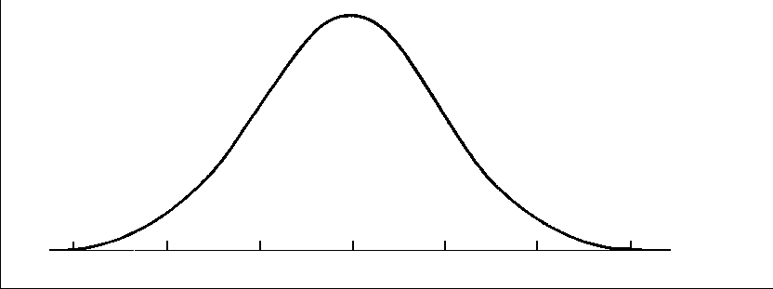

28. What percentage of pennies will weigh between 1.5 and 3.5g?

29. What percentage of pennies will weigh less than 2.5g?

30. What percentage of pennies will weigh more than 4g?