Math 3/3H Name:__________________________________Per:___

4.4 Graphing Rationals

Graph the following rational functions without a calculator. Then find the key features.

1. 

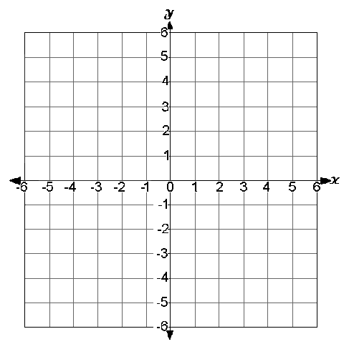

**Domain:** ___________________________________

**Range:** ____________________________________

**Vertical Asymptotes:** ________________________

**Horizontal Asymptotes:** ­­­­­______________________

**Continuity:** ________________________________

**x-intercepts:** _______________________________

**y-intercepts:** _______________________________

**Increasing:** ________________________________

**Decreasing:** ________________________________

**Positive:** ___________________________________

**Negative:** __________________________________

**Relative Max/s:** _____________________________

**Relative Min/s:** _____________________________

**Symmetry:** ________________________________

**End Behavior:** ______________________________

Graph the function and identify the key features.



**Domain:** ___________________________________

**Range:** ____________________________________

**Vertical Asymptotes:** ________________________

**Horizontal Asymptotes:** ­­­­­______________________

**Continuity:** ________________________________

**x-intercepts:** _______________________________

**y-intercepts:** _______________________________

**Increasing:** ________________________________

**Decreasing:** ________________________________

**Positive:** ___________________________________

**Negative:** __________________________________

**Relative Max/s:** _____________________________

**Relative Min/s:** _____________________________

**Symmetry:** ________________________________

**End Behavior:** ______________________________

Graph the function and find the key features.

1. 



**Domain:** ___________________________________

**Range:** ____________________________________

**Vertical Asymptotes:** ________________________

**Horizontal Asymptotes:** ­­­­­______________________

**Continuity:** ________________________________

**x-intercepts:** _______________________________

**y-intercepts:** _______________________________

**Increasing:** ________________________________

**Decreasing:** ________________________________

**Positive:** ___________________________________

**Negative:** __________________________________

**Relative Max/s:** _____________________________

**Relative Min/s:** _____________________________

**Symmetry:** ________________________________

**End Behavior:** ______________________________

Find when f(x)=g(x).

|  |  |
| --- | --- |
| 1. , | 1. , |
| 1. ,   Find the Missing Side | 1. , |
| 8. | 9. |  |
| 10. |  |

