Math 3H Name __________________________________

4.5 Graphing Rational Functions Day 2 Period ______________

**Example 1:** Graph the function  and identify the key features.

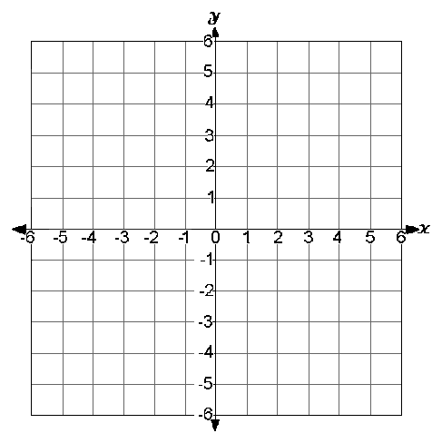

**Domain:** ___________________________________

**Range:** ____________________________________

**Vertical Asymptotes:** ________________________

**Horizontal Asymptotes:** ­­­­­______________________

**Continuity:** ________________________________

**x-intercepts:** _______________________________

**y-intercepts:** _______________________________

**Increasing:** ________________________________

**Decreasing:** ________________________________

**Positive:** ___________________________________

**Negative:** __________________________________

**Relative Max/s:** _____________________________

**Relative Min/s:** _____________________________

**Symmetry:** ________________________________

**End Behavior:** ______________________________

**Example 2:** Graph the function  and identify the key features.



**Domain:** ___________________________________

**Range:** ____________________________________

**Vertical Asymptotes:** ________________________

**Horizontal Asymptotes:** ­­­­­______________________

**Continuity:** ________________________________

**x-intercepts:** _______________________________

**y-intercepts:** _______________________________

**Increasing:** ________________________________

**Decreasing:** ________________________________

**Positive:** ___________________________________

**Negative:** __________________________________

**Relative Max/s:** _____________________________

**Relative Min/s:** _____________________________

**Symmetry:** ________________________________

**End Behavior:** ______________________________

Graph the function without using a calculator. Show all work to graph.

|  |  |
| --- | --- |
| **3.**  http://donnayoung.org/thumbs/math-img/coordinate-clip-gr.gif | **4.**  http://donnayoung.org/thumbs/math-img/coordinate-clip-gr.gif |
| **5.**  http://donnayoung.org/thumbs/math-img/coordinate-clip-gr.gif | **6.**  http://donnayoung.org/thumbs/math-img/coordinate-clip-gr.gif |

**Write the equation of g(x) after the given transformations are applied to f(x).**

|  |  |
| --- | --- |
| 7. given   1. Reflect across the x-axis 2. Right 1 3. Shrink | 8. given   1. Down 1 2. Reflects across y 3. Stretch 4 |

**Where does the point (0,0) move when the given transformations are applied to the given parent function?**

|  |  |
| --- | --- |
| 9. Parent Function:  Transformation: | 10. Parent Function:  Transformation: |

**Graph the piecewise function.**

|  |  |
| --- | --- |
| **11.**  http://donnayoung.org/thumbs/math-img/coordinate-clip-gr.gif | **12.**  http://donnayoung.org/thumbs/math-img/coordinate-clip-gr.gif |