Math 3H Name:_________________________________Per:___

5.1 Area of a Triangle/Law of Sines

Find the area of each triangle. Round your answer to the nearest thousandth (3 decimal places).
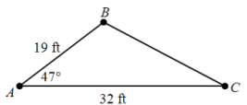 | 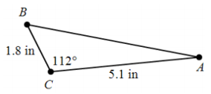
- $B=36°, a=3 cm, c=6cm$ | - $A=48°, b=20 m, c=40m$
- $B=33°, a=12 ft, c=5.5 ft$ | - $C=102°, a=16 cm, b=20 cm$
- $A=76°, b=11 m, c=24 m$ | - $B=101°, a=10 cm, c=22 cm$
- A surveyor wants to mark off a triangular parcel with an area of 0.5 acres (1 acre is equivalent to 43,560 ${ft}^{2}$). One side of the triangle extends 220 feet along a straight road. A second side extends at an angle of $75°$ from the first side. How long should the second side be?

Use the Law of Sines to solve each triangle (Find missing angles and missing sides). Round each answer to the nearest thousandth.

- $A=40°, B=30°, b=10$ | - $A=70°, C=62°, a=7.3$ | - $A=60°, B=45°, b=3.7$
- $A=40°, a=20, b=15$ | - $B=70°, b=14, c=9$ | - $C=50°, b=20, c=30$
- At forest ranger station A, the ranger notices a fire in the direction 32$°$ east of north. Another ranger at station B 10 miles due east of station A, sights the same fire on a line 48$°$ west of north. Find the distance from each ranger station to the fire.

- A road slopes 10$°$ above the horizontal, and a vertical telephone pole stands beside the road. The angle of elevation of the sun is 62$°$, and the pole casts a 14.5 foot shadow downhill along the road. Find the height of the telephone pole.

