Math 3H Name:____________________________Per:___

5.3 Law of Cosines

Solve the triangle. Round your answer to the nearest thousandth.

- $C=27°, a=5, b=9$ | - $A=100°, b=4, c=1$ | - $B=40°, a=80, c=78$
- $a=2, b=5, c=4$ | - $a=10, b=12, c=21$ | - $a=5, b=7, c=10$

7-8 Determine if you would use the Law of Sines or the Law of Cosines to find the missing value.
- 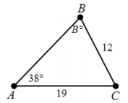  9-12 Find the missing value. | - 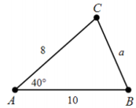
- $b=4, c=8, A=46°;find a$. | - $a=10, c=8.9, A=63°;find b$.
- $a=18, b=17, c=12;find m∠C$.  - Use the law of sines or cosines to solve the problem. Observers 2.32 miles apart see a hot air balloon directly between them but at the angles of elevation 28$°$, and 37$°$. Find the altitude of the balloon. | $12. a=14, B=41°, C=62°;find b$.  - The bases on a baseball diamond are 90 feet apart, and the front edge of the pitcher’s mound is 60.5 feet from the back corner or home plate. Find the distance from the center of the front edge of the pitcher’s mound to the far corner of the base.

- Tony must find the distance from A to B
On opposite sides of a lake. He locates a point
C that is 860 feet from A and 175 feet from
B. He measures the angle at C to be 78$°.$
Find the distance AB.

- Utah scores on the ACT. If the scores were distributed normally with a mean of 21 and a standard deviation of 2. Draw a normal curve, label the mean and three standard deviations above and below the mean.

- What percentage of scores are between 17 and 25?
- What percentage of scores are between 19 and 23?
- What percentage of scores are between 15 and 25?
- What percentage of scores are less than 23?
- What percentage of scores are greater than 25?

