Math 3/3H Name ________________________________________
6.1 The Unit Circle Period ______________
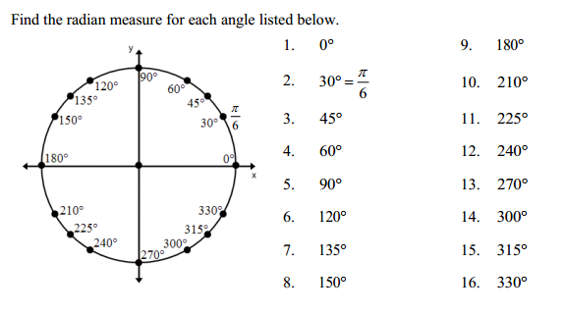

Convert each degree measure into radians.
17. -290⁰ 18. 345⁰ 19. 970⁰ 20. -510⁰ 21. 150⁰

22. 315⁰ 23. 210⁰ 24. 90⁰ 25. 180⁰ 26. 225⁰

Convert each radian measure into degrees.
27. $\frac{3π}{2}$ 28. $\frac{7π}{2}$ 29. $\frac{5π}{4}$ 30. $\frac{16π}{7}$ 31. $\frac{5π}{3}$

32.$\frac{9π}{4}$ 33. $\frac{π}{2}$ 34. $π$ 35. $\frac{7π}{4}$ 36. $\frac{8π}{3}$

Fill in both unit circles below. (Practice memorizing)
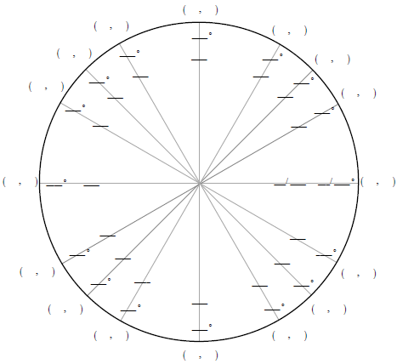

List the order pair for the angle measure.
37. 180⁰ = ( , ) 38. 240⁰ = ( , ) 39. 330⁰ = ( , )

40. $π$ = ( , ) 41. $\frac{4π}{3}$ = ( , ) 42. $\frac{11π}{6}$ = ( , )

List the value according to the angle.
43. x-value at 45⁰ 44. y-value at 150⁰ 45. x-value at 210⁰

46. y-value at $\frac{3π}{4}$ 47. x-value at $\frac{π}{3}$ 48. y-value at $\frac{5π}{3}$

