Math 3H Name ________________________________________
6.2 The Unit Circle Day 2 Period _______________
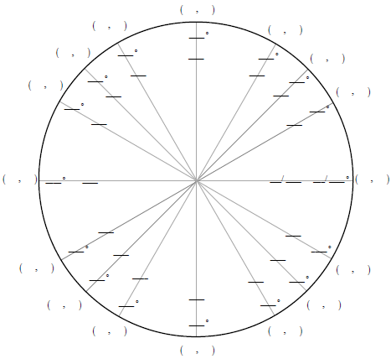
Fill in the unit circle below.

Sine is the ________ value.

Cosine is the ________ value.

Tangent is ________ value divided by ________ value.

- cos 135⁰ = $-\frac{\sqrt{2}}{2}$ | - tan 270⁰ = | - sin 300⁰ = | - cos 45⁰ =
- tan 60⁰ = | - sin 120⁰ = | - cos 180⁰ = | - tan 0⁰ =
- sin 210⁰ = | - cos 240⁰ = | - tan 225⁰ = | - sin 315⁰ =
- $\sin{\frac{11π}{6}}$ = | - $\cos{\frac{π}{6}}$ = | - $\tan{\frac{5π}{6}}$ = | - $\sin{\frac{π}{2}}$ =
- $\cos{π}$ = | - $\tan{\frac{7π}{4}}$ = | - $\sin{\frac{5π}{4}}$ = | - $\cos{\frac{7π}{6}}$ =
- $\tan{\frac{3π}{2}}$ = | - $\sin{\frac{π}{4}}$ = | - $\cos{\frac{2π}{3}}$ = | - $\tan{\frac{π}{2}}$ =

Use the unit circle to find the exact value.

Refer to the diagram. Give the letter that could stand for the function value.
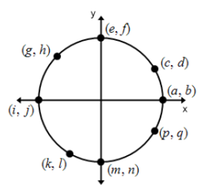
- $\sin{{180}^{0}}$ = j | - $\cos{{270}^{0}}$ | - $\cos{{30}^{0}}$
- $sin{135}^{0}$ | - $\cos{0^{0}}$ | - $\sin{{330}^{0}}$
- $\sin{\frac{π}{2}}$ | - $\cos{\frac{4π}{3}}$ | - $\cos{\frac{3π}{4}}$
- $\sin{\frac{4π}{3}}$ | - $\cos{\frac{11π}{6}}$ | - $\sin{2π}$

Refer to the diagram. For the indicated point, tell if the value is positive, negative or neither.
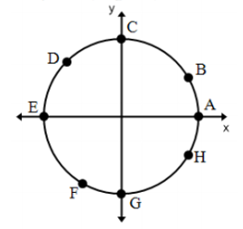
- Cos G =Neither | - Sin C | - Sin H
- Cos D | - Cos B | - Sin E
- Sin B | - Sin F | - Sin G
- Cos A | - Cos E | - Cos C
Use the unit circle to find the exact values.
- $cot\frac{11π}{6}$ | - $csc\frac{π}{6}$ | - $sec\frac{5π}{6}$
- $cot\frac{π}{2}$ | - $csc\frac{7π}{6}$ | - $sec\frac{7π}{4}$
- $\cot{210}$ | - $\csc{225}$ | - $\sec{240}$
- $\cot{45}$ | - $\csc{120}$ | - $\sec{60 }$

