Math 3/3H Name ____________________________________

8.1 Box Problem – Maximizing Volume Period _________________

Use an equation to solve the problem.

1. A square of side x inches is cut out of each corner of a 25 in. by 15 in. piece of cardboard, and the sides are folded up to form an open-topped box.

a. Draw a model to demonstrate this problem.

b. Write a function for the volume of the box.

c. State the domain.

d. Use your graphing calculator to determine the dimensions that will produce the box of maximum volume then, state the dimensions of the box.

Length =
Width =
Height =
Maximum Volume =

2. A square of side x inches is cut out of each corner of a 13 in. by 7 in. piece of cardboard, and the sides are folded up to form an open-topped box.

a. Draw a model to demonstrate this problem.

b. Write a function for the volume of the box.

c. State the domain.

d. Use your graphing calculator to determine the dimensions that will produce the box of maximum volume then, state the dimensions of the box.

Length =
Width =
Height =
Maximum Volume =

3. A square of side x inches is cut out of each corner of a 20 in. by 8 in. piece of cardboard, and the sides are folded up to form an open-topped box.

a. Draw a model to demonstrate this problem.

b. Write a function for the volume of the box.

c. State the domain.

d. Use your graphing calculator to determine the dimensions that will produce the box of maximum volume then, state the dimensions of the box.

Length =
Width =
Height =
Maximum Volume =

4. A square of side x inches is cut out of each corner of a 10 in. by 6 in. piece of cardboard, and the sides are folded up to form an open-topped box.

a. Draw a model to demonstrate this problem.

b. Write a function for the volume of the box.

c. State the domain.

d. Use your graphing calculator to determine the dimensions that will produce the box of maximum volume then, state the dimensions of the box.

Length =
Width =
Height =
Maximum Volume =

5. A box with a square bottom and a volume of 3000 centimeters can be made by cutting 6cm squares from the corners of a piece of cardboard and then turning up the sides.

a. Draw a model to demonstrate this problem.

b. What should be the dimensions of the piece of cardboard?
6. A box with a square bottom and a volume of 2000 centimeters can be made by cutting 5cm squares from the corners of a piece of cardboard and then turning up the sides.

a. Draw a model to demonstrate this problem.

b. What should be the dimensions of the piece of cardboard?

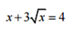
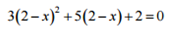
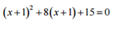
Solve each equation by factoring
7. 8. 9.

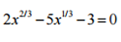
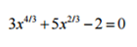
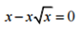
10. 11. 12. .

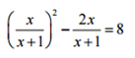
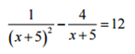
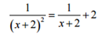
13. 14. 15.

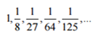
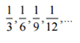
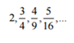
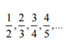
16. 17. 18. 19.

