Math 3/3H Name:___________________________________Per:___

8.5 U-Substitution

Solve each equation using U-Substitution.

1. ${\left(x+3\right)}^{2}-2\left(x+3\right)-24=0$ | 2. ${\left(x+1\right)}^{2}+8\left(x+1\right)+15=0$ | 3. $3{\left(2-x\right)}^{2}+5\left(2-x\right)+2=0$
4. $x+\sqrt{x}=12$ | 5. $x+3\sqrt{x}=4$ | 6. $x^{\frac{1}{2}}-2x^{\frac{1}{4}}+1=0$
7. $\frac{1}{{\left(x+2\right)}^{2}}=\frac{1}{x+2}+2$ | 8. $\frac{1}{{\left(x+5\right)}^{2}}-\frac{4}{x+5}=12$ | 9. ${\left(\frac{x}{x+1}\right)}^{2}-\frac{2x}{x+1}=8$
10. $x^{\frac{2}{3}}+9x^{\frac{1}{3}}+20=0$ | 11. $2x^{\frac{2}{3}}-5x^{\frac{1}{3}}-3=0$ | 12. $x^{\frac{4}{3}}-6x^{\frac{2}{3}}+9=0$
13. $3x^{\frac{4}{3}}+5x^{\frac{2}{3}}-2=0$ | 14. $x-3x\sqrt{x}=0$ | 15. $x-x\sqrt{x}=0$
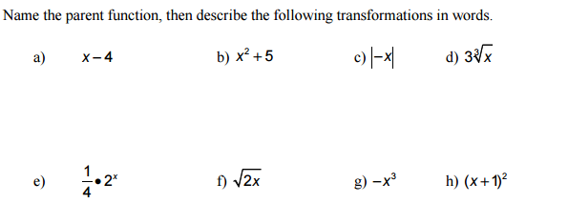
16.

17. Name each parent function and place your answer on the line.
