- Find the length of the side PR.
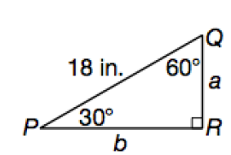

- Find the lengths of the other two sides of a right triangle if the length of the hypotenuse is $4\sqrt{2}$ and one of the angles is 45⁰?

- Figure DEFG is a square. If EG=4, what is the area of the square?
- 4
- $4\sqrt{2}$
- 8
- 16
- 32

- An equilateral triangle has a side with a length of 10. What is the area of the triangle?
- $5\sqrt{2}$
- 25
- $25\sqrt{3}$
- $50\sqrt{3}$
- $100\sqrt{2}$

- Points A(1, 0), B(8, 0), and C(3, 4) are the vertices of a triangle. What is the area of this triangle?
- 5
- 10.5
- 14
- 16
- 28

- A boat travels to a small island. The island is located 9 miles east and 12 miles north of the boat’s departure point. About how many miles is the island from the departure point?
- 3
- 15
- 21
- 225
- $\sqrt{63}$

- A triangle has sides of length 4 inches and 7.5 inches. Which of the following cannot be the length of the third side?
- 3.0 inches
- 4.0 inches
- 5.0 inches
- 5.5 inches
- 9.5 inches

- What is the perimeter of a 30-60-90 triangle with a long leg of 12 inches?
- $6\sqrt{3}+12$
- $4\sqrt{3}+18$
- $6\sqrt{3}+18$
- $12\sqrt{3}+12$
- $12\sqrt{3}+18$

- Points Y and Z lie on the circle with center O such that arc YOX is equilateral. What is the probability that a randomly selected point in the circle lies inside minor arc YZ?
- 1/360
- 1/60
- 1/6
- 6/10
- 5/6

- Two spheres, on with radius 14 and one with radius 8, are tangent to each other. If T is any point on one sphere and W is any point on the other sphere, what is the maximum possible length of TW?
- 14
- 22
- 28
- 36
- 44

- If the length of a minor arc formed by two radii in a circle is 1/40 of the circumference, what is the arc’s measurement in degrees?
- 3
- 6
- 9
- 12
- 15

- If the point (8, 6) lies on a circle with a center at (0, 0) what is the area of the circle?
- $18π$
- $36π$
- $48π$
- $64π$
- $100π$

- ABCD is a rectangle. If the area of triangle ABE is 40, what is the area of the rectangle?
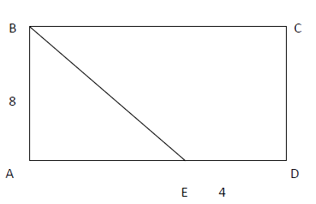
- 20
- 28
- 40
- 80
- 112

- In a square EFGH, GH = 3, what is the length of the diagonal FH?
- $3\sqrt{2}$
- $3\sqrt{3}$
- 6
- $6\sqrt{2}$
- 9

- Two lines, q and l, which never intersect, are both tangent to circle T. If the smallest distance between any point on q and any point on l is four less than triple that distance, what is the area of circle T?
- $π$
- $\frac{π}{4}$
- $2π$
- $4π$
- $9π$

