Math 3/3H

January CM Review – Cross Sections and Rotations

- What is the shape of the cross section resulting from the intersection of a cube and a vertical plane?

- Given a cylinder, what two-dimensional shape will result from a 90 degree, vertical slice through both bases.
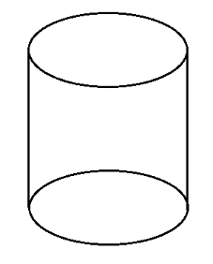

- Given a square-based pyramid, what two-dimensional shape will result from a horizontal slice parallel to the base?
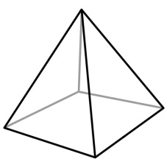

- What is the cross section that results from cutting a cone with a vertical plane?
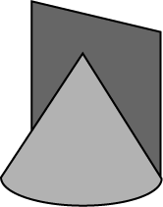

- Which figure has the same vertical and horizontal cross sections?

- Consider the following figure.
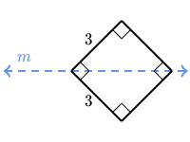
What solid 3-dimensional figure is created by rotating the figure about line m?

- Consider the following figure.
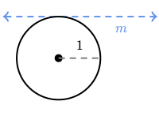
What solid 3-dimensional figure is created by rotating the figure about line m?

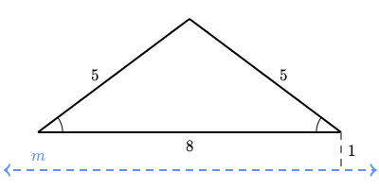
- Consider the following figure.

What solid 3-dimenstional figure is created by rotating the figure about line m?

- Which shape was rotated to create the following figure?
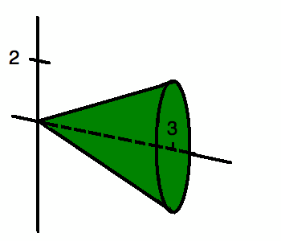

- Which function would have to be rotated to create the following image?

