RS 1: Name:___________________
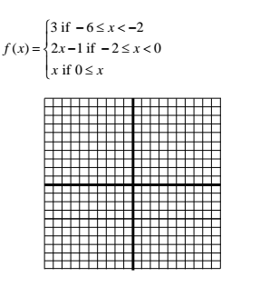
Graph each piecewise:
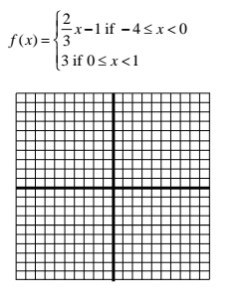

RS 1: Name:___________________
Graph each piecewise:

RS 2: Name:_______________
- Solve the system. 2. Solve the inequality.
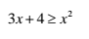
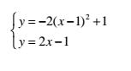

3. Write the function for the graph. 4. Write the function of the graph.
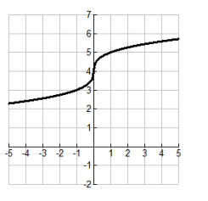
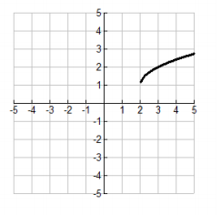

RS 2: Name:_______________
- Solve the system. 2. Solve the inequality.

3. Write the function for the graph. 4. Write the function of the graph.

RS 3: Name:____________________
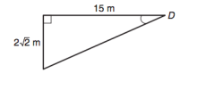
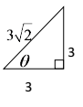
- Find all 6 Trigonometric Ratios. 2. Find the missing side.

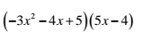
3. Simplify 4. Simplify
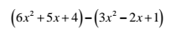

RS 3: Name:____________________
- Find all 6 Trigonometric Ratios. 2. Find the missing side.

3. Simplify 4. Simplify

RS 4: Name:____________________
Solve each equation by using the Quadratic Formula.
- $x^{2}+8x+5=0$ 2. $x^{2}+3=-6x+8$

If the discriminant is
3. negative then there are _______________ solutions.
4. positive then there are _________________ solutions.
5. 0 then there are _________________ solutions.

RS 4: Name:____________________
Solve each equation by using the Quadratic Formula.
- $x^{2}+8x+5=0$ 2. $x^{2}+3=-6x+8$

If the discriminant is
3. negative then there are _______________ solutions.
4. positive then there are _________________ solutions.
5. 0 then there are _________________ solutions.

RS 5: Name:____________________
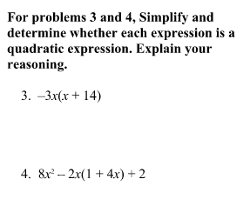
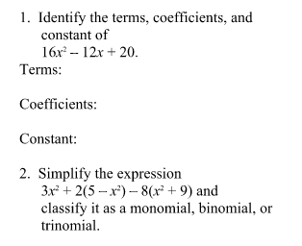

RS 5: Name:____________________

RS 6: Name:____________________
Solve each equation for x.
- $x^{2}=81$ 2. $x^{2}=-25$

3. $x^{2}-5=15$ 4. $x^{2}+4=3x^{2}-10$

RS 6: Name:____________________
Solve each equation for x.
- $x^{2}=81$ 2. $x^{2}=-25$

3. $x^{2}-5=15$ 4. $x^{2}+4=3x^{2}-10$

