___ ___ ___ ___ ___ ___ ___ ___ ___ ___ ___ ___ ___ ___ ___ ___ ___
1 2 3 4 5 6 7 8 9 10 11 12 13 14 15 16 17

Simplify each expression.
- $\left(5m-7m^{4}-3m^{2}\right)-({2m}^{2}+7m+m^{4})$
P - $-11m^{4}-{5m}^{2}-2m$
S - $-8m^{4}-{5m}^{2}-2m$
N - $-7m^{4}-{5m}^{2}-2m$
R - $-11m^{4}-{5m}^{2}+6m$

- $\left(2n^{4}-1+5n^{3}\right)+({6n}^{4}-7+{5n}^{3})$
T - $8n^{4}+{10n}^{3}-8$
M - $n^{4}+{10n}^{3}-16$
O - $n^{4}+{10n}^{3}-14$
D - $8n^{4}+{10n}^{3}-16$

Find the product.
- $\left(a+2\right)\left(7a^{2}+7a-2\right)$
U - ${7a}^{3}+{21a}^{2}+12a-4$
O - ${8a}^{3}-{10a}^{2}-31a+42$
A - ${7a}^{3}+{29a}^{2}+9a+20$
E - ${21a}^{3}+{46a}^{2}-21a+2$

- $(4k+7)({8k}^{2}-4k+7)$
T - ${24k}^{3}+{6k}^{2}±54k+24$
D - ${32k}^{3}+{40k}^{2}+49$
F - ${7k}^{3}+{58k}^{2}+17k+8$
H - ${20k}^{3}+k^{2}-20k+6$

Simplify
- $\left(-5-7i\right)-\left(-1+i\right)$
M - $-4-6i$
N - $-6+8i$
Y - $-4-8i$
R - $-4+6i$
- $\left(7+2i\right)\left(-6+i\right)$
F - $-44-5i$
B - $-42+7i$
I - $40-19i$
O - $-44+6i$

Solve.
- $n^{2}+8n+16=0$
O - $-4$
C – $3, 4$
W - $-6, 2$
D - $-3, -4$

Solve.
- ${5r}^{2}-8r+8=0$
K - $\frac{6±5\sqrt{3}}{3}$
S - $\frac{6±i\sqrt{3}}{3}$
B - $8, -\frac{14}{3}$
R - $\frac{4±2i\sqrt{6}}{5}$

Solve.
- ${7x}^{2}+5=348$
L - $±71$
Y - $±7$
V - $±69$
S - $±\sqrt{71}$

10. What is the vertex of the function graphed below?
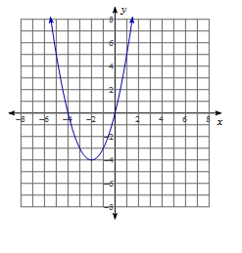

O - (-2, -4); minimum
I - (-2, -4); maximum
A - (2, 4); minimum
E - (2, 4); maximum

11. What is the vertex of the function graphed below?
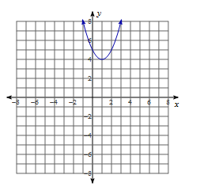

E - (-1, -4); minimum
U - (1, 4); minimum
O - (1, -4); maximum
A - (-1, 4); maximum

Which graph represents the new function?
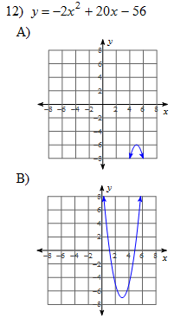
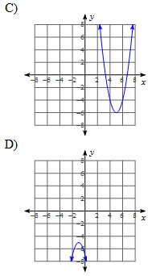

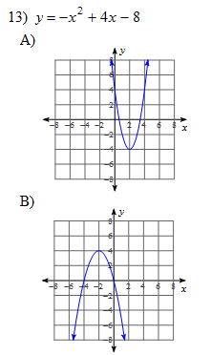
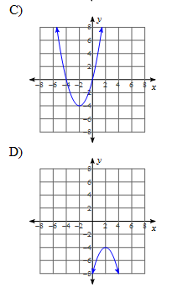

Find the discriminant of each quadratic equation then state the number and type of solutions.
14. ${-4x}^{2}+4x-1=0$ 15. ${-3x}^{2}+6x-3=0$
E - 0; one real solution A - 0; two imaginary solutions
R - 0; two real solutions B - -111; two imaginary solutions
K - 65; two real solutions S - 0; one real solution
D - 32; two real solutions N - 72; two real solutions

Factor over the complex number system.
16. x² + 25 17. x²+16
T – (x+5i)(x-5i) ? – (x-4i)²
W – (x-5i)² ! – (x+4i)(x-4i)
R – (x+5)² . – (x+4i)²
L – (x-5)(x+5) : - (x-4)(x+4)

