Math 3/3H

Unit 2 Review

**No work=No points**

Describe the end behavior of the polynomial function by finding  and .

1. 
2. 
3. 

Make a **table** that shows the **zeros** of the polynomial function, their **multiplicities** and whether or not they **cross or touch** the x-axis. Make sure the table is complete.

1. 
2. 
3. 

Use a graphing calculator to approximate the real zeros of the function defined by f(x). If necessary, round your answers to the nearest hundredth.

1. 

1. 

Graph the function without the calculator. (Use a table to show your work.)

1. 

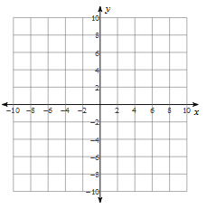

1. 



Factor to find the zeros of the function.

1. 
2. 
3. 

Find a cubic function in standard form with given zeros. (#15 Honors only).

1. 
2. 

Find the remainder.

1. 
2. 

Determine whether the second polynomial is a factor of the first.

1. 
2. 

Divide using long division.

1. 
2. 
3. The area of a rectangle can be modeled y the function. If the width can be modeled by  , what function can be used to model the length?

Write a polynomial function of minimum degree. (#23 and 24 Honors only).

1. 
2. 

Factor the function over the complex numbers.

1. 
2. 
3. 
4. 