Solve each of the systems of equations graphically.
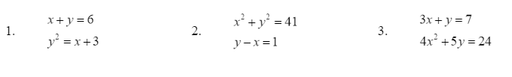

Solve each of the systems of equations algebraically.
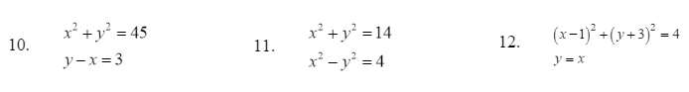

Solve each system.
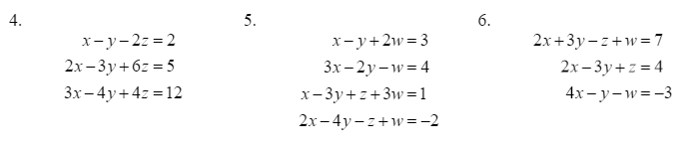
Find the inverse of each matrix.
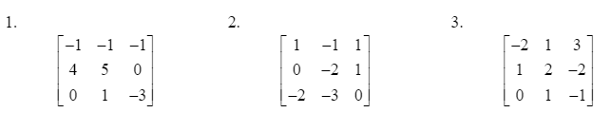

Solve using the inverse matrix.
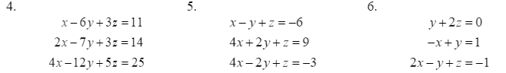

Solve the inequalities.

- x² + 4x +3 < 0

- x² + 9x ≥ -14

- $x^{2}-2x-3>0$

- -3x²+5x+2 ≤ 0

- $\frac{1}{x-3}≤0$

- $\frac{2x+1}{x-5}<0$

- $\frac{-2}{x+4}<0$

- $\frac{x+3}{2x-5}≥0$

- The largest size envelope that be mailed with a large envelope rate is 2 inches longer than it is wide. The area is 143 in². Find the length and the width.

- The base of a triangular tabletop is 15 inches longer than the height. The area is 125 in². Find the height and the base.

- Jill wants to build a rectangular cage for her hamster. The length must be 3 feet longer than the width. Her room is very small so she has to have a cage with an area of 30 ft². What should the dimensions of the cage be?

- Farmer Joe wants to build a pig pen with one side against his barn. He has 40 ft of fence to use. What dimensions will maximize the pig pen?

- Principal Judd wants to put a fence all the way around his school’s soccer and football field. The fields are separated with a fence as well. The area of each field is the same. He has 800 yards of fencing to work with and he wants to use all of the fencing. What would be the dimensions to maximize the soccer field?

- You are dropping eggs from the roof of your hotel. The roof is approximately 185 feet from the ground. How long is the egg more than 20 feet above the ground? Use h(t)=-16t²+v₀t+h₀ to help you.

- Batman was visiting Robin and accidentally knocked his mask off the ledge. Catwoman is standing directly below the ledge. If the ledge is 25 feet above the ground and Catwoman is 5 feet tall, how long does she have to move before the mask hits her on the head?

- You dive off of a cliff at Lake Powell from a height of 40 feet. How long does it take before you get wet?

- A rocket is launched from a 10 m high platform at an initial velocity 150m/sec. When will the rocket exceed 200 m? Use h(t)=-4.9t²+v_{o}t+h₀ to help you.

- How far will an object fall in 2 seconds if it thrown downward at an initial velocity of 5m/sec from a height of 2000 m?

