8.1 Right Triangle Trig (G.SRT.6)
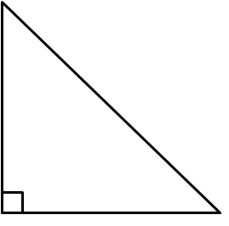
Pythagorean Theorem:

Trigonometry –

Trig Ratios: SOHCAHTOA

sine cosecant

cosine secant

tangent cotangent

Identify the six trig ratios for the triangles in the examples below:
Example 1:  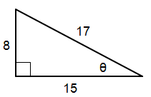 | 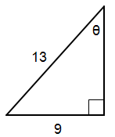  Example 2:

Use a calculator to find each value.

Ex. 3) $\sin\left(9°\right)$ | Ex. 4) $\cos\left(37°\right)$ | Ex. 5) $\tan\left(48°\right)$

8.2 Solving a Triangle

We can use the inverse trig functions to find the measure of an angle.

a. $\sin^{-1}{(0.5)}$ | b. $\cos^{-1}{(0.86)}$ | c. $\tan^{-1}{(6)}$

Write an equation using the different trig functions to solve for x.
Find the measure of each side indicated. Round to the nearest tenth.

Example 1:  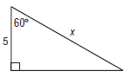 | Example 2:  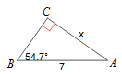

Find the measure of each angle indicated. Round to the nearest tenth.
Example 3:  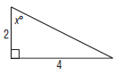 | Example 4:  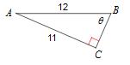

Solve each triangle. Round answers to the nearest tenth.
Example 5:
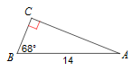

8.3 Angles of Elevation and Depression (G.SRT.8, pg 286)
Vocab:
Angle of Elevation:  Angle of Depression: | 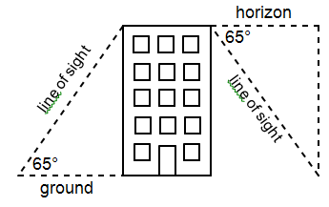

*Hint: Drawing a picture will help to set up the triangles.

Example 1
You are standing 196 feet from the base of an office building in downtown Salt Lake City. The angle of elevation to the top of the building is 65$°$ Find the height of the building.

Example 2
John is standing on the roof of a building that is 300 feet tall and sees Sarah standing on the ground. If the angle of depression is 60$°$ how far away is Sarah from John?

Example 3
A kite has 25 feet of string. The wind is blowing the kite to the west so that the angle of elevation is 40$°$. How far has the kite traveled horizontally?

Example 4
A sledding run is 400 yards long with a vertical drop of 40.2 yards. Find the angle of depression of the run.

