Math 3H

Unit 8 Review

Find the average rate of change for each function of the specified interval.

1. on [-7, 5]
2.  on [-4, -2]
3. on [-5, -4]

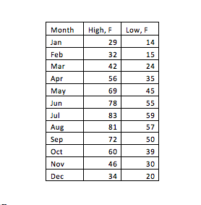Use the table to answer questions 4 and 5.

1. What is the average high rate of change from May to August? **Remember to write a sentence.**
2. What is the average low rate of change from July to November? **Remember to write a sentence.**

Name ____________________________________

Period ______________

1. Using the graph of f(x) shown, find the average rate of change on the interval [-3, 3]

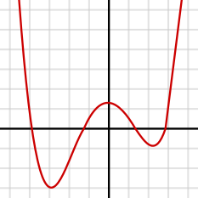

Use technology to find when *f(x)* = *g(x).*

1.  and 
2.  and 

1.  and 

Solve

1. 
2. 
3. The volume of a box is 600 cubic meters. If the width is twice as long as the height and the length is two more than the width, what are the dimensions of the box.
4. Bill can row 3 mph in still water. It takes him 3.6 hours to go 3 miles upstream. Find the speed of the current.
5. You are given a 13cm x 15cm piece of cardboard and asked to make an open-top box with maximum volume by cutting equal sized squares from each corner.
6. Draw and label a model to describe the situation.
7. Write an equation to find the volume of the box.
8. What is the domain of the situation?
9. Give one example the height of the box could be and the volume of this box.
10. Use your calculator to find the
    1. Max Vol:
    2. Length:
    3. Width:
    4. Height

Solve each inequality. Write your answer graphically and in interval notation.

1. 
2. 
3. A projectile is fired straight upward from ground level with an initial velocity of 96 feet per second. During which interval of time will the projectile’s height exceed 80 feet?

Solve using U-Substitution

1. 
2. 
3. 
4. Draw and analyze the function.

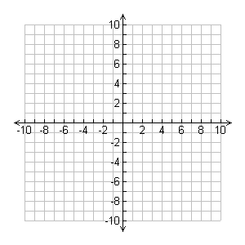 

Domain:

Holes:

Vertical Asymptotes:

Horizontal Asymptotes:

x - Intercepts

y – Intercepts

Symmetry: